# 

## Front End Engineering-II

Project Report

Semester-III (Batch-2023)

Travel Website- LiveLikeLocals



**Supervised By: Submitted By:**

Faculty Name Amisha Pundir, 2310991771

**Thirupathy M** Driksha Thakur, 2310991822

Gracy Mahajan, 2310991827

**Department of Computer Science and Engineering**

**Chitkara University Institute of Engineering & Technology,**

**Chitkara University, Punjab**

**ABSTRACT**

LiveLikeLocals is a travel website dedicated to providing travellers with authentic, immersive experiences that allow them to engage deeply with the culture and daily life of the destinations they visit. The platform connects users with local hosts and guides who offer personalized activities, such as cooking traditional dishes, exploring hidden neighbourhoods, and participating in cultural traditions. By focusing on local perspectives, LiveLikeLocals promotes sustainable tourism, ensuring that economic benefits reach local communities while fostering cultural exchange. The website also emphasizes eco-friendly practices and encourages slow travel, helping users to create meaningful connections with both people and places. Through its innovative approach, LiveLikeLocals aims to redefine travel, offering a richer, more responsible way to explore the world by truly living like a local. The driving philosophy behind LiveLikeLocals is the belief that the most meaningful travel experiences come from authentic interactions with local people, traditions, and environments. The platform is built around the idea that every destination has a unique character, shaped by its residents, culture, and history. By connecting travellers directly with local hosts and guides, LiveLikeLocals enables visitors to explore a destination through the lens of those who know it best—the people who live there. This approach offers a stark contrast to the typical tourist experience, which often involves visiting well-trodden sites and following generic itineraries. Instead, LiveLikeLocals encourages travellers to take part in activities that locals enjoy in their daily lives, such as cooking traditional dishes, exploring off-the-beaten-path neighbourhoods, attending community events, or learning local crafts. These experiences provide deeper insights into the culture and foster a genuine understanding and appreciation of the place.

**TABLE OF CONTENTS**

|  |  |  |
| --- | --- | --- |
| Sr.no | Section | Page no |
| 1) | **Introduction** | **1-2** |
| 2) | **Problem Definition and Requirements** | **2-3** |
| 3) | **Modules** | **3-4** |
| 4) | **Project Snapshots** | **5-6** |
| 5) | **Conclusion** | **7-8** |
| 6) | **References** | **9-11** |

1. **INTRODUCTION**

In today’s travel landscape, there is a growing demand among travellers for more meaningful and authentic experiences. This shift reflects a broader trend away from traditional tourism, which often revolves around visiting popular landmarks and staying in standardized accommodations. Instead, modern travellers are increasingly seeking to engage with the local culture, traditions, and communities of the places they visit. Here’s why offering authentic, local experiences is crucial:

**Cultural Immersion**: Authentic experiences allow travellers to deeply immerse themselves in the culture of a destination. Rather than just observing from the outside, they participate in daily activities, customs, and traditions, gaining a richer and more nuanced understanding of the local way of life.

**Personal Connections**: Engaging with local hosts and guides fosters personal connections that go beyond the superficial interactions typical of traditional tourism. These connections can lead to more memorable and rewarding experiences, as travellers hear stories, share meals, and learn directly from the people who call the destination home.

**Sustainable Tourism**: Authentic travel experiences often support sustainable tourism practices. By staying in locally-owned accommodations, dining in local restaurants, and participating in activities led by local guides, travellers contribute directly to the local economy. This approach helps to ensure that the benefits of tourism are distributed more equitably, supporting community development and preserving cultural heritage.

**Unique Experiences**: Authentic experiences are often unique and tailored to the specific characteristics of a destination. They provide travellers with the opportunity to do things that are not available anywhere else in the world, such as learning to cook traditional dishes, participating in local festivals, or exploring hidden gems known only to locals.

**Deeper Understanding and Appreciation**: By engaging with the local community, travellers gain a deeper appreciation for the culture, history, and challenges faced by the people they meet. This can lead to more responsible and respectful travel behaviour, as visitors become more aware of the impact of their actions on the destination and its residents.

The website you are developing, based on the "LiveLikeLocals" theme, is designed specifically to address the growing desire for authentic, local travel experiences. Here's how your platform meets this need:

**Connection with Local Hosts and Guides**: The website acts as a bridge between travellers and local hosts or guides who offer personalized, immersive experiences. By facilitating direct interaction, the platform ensures that travellers can connect with knowledgeable locals who can provide insights into the culture, history, and everyday life of the destination.

**Curated Local Experiences**: Your website offers a carefully curated selection of activities that go beyond typical tourist attractions. Whether it’s a cooking class in a local’s home, a guided walk through a historic neighbourhood, or participation in a traditional ceremony, the experiences are designed to be authentic and immersive, giving travellers a true taste of what it means to live like a local.

**Personalized Itineraries**: Recognizing that each traveller is unique, the website allows users to create personalized itineraries based on their interests and preferences. This feature ensures that travelers can tailor their experiences to match their desired level of engagement with local culture, whether they prefer hands-on activities or more observational experiences.

**Support for Local Economies**: By connecting travellers directly with local service providers, the website helps ensure that tourism dollars stay within the community. This not only supports local businesses but also promotes the preservation of cultural traditions and crafts that might otherwise be overshadowed by mass tourism.

**Emphasis on Sustainable and Responsible Tourism**: The website encourages responsible travel by promoting eco-friendly practices and offering experiences that have a minimal impact on the environment. Travelers are educated on how to reduce their carbon footprint, respect local customs, and engage in ways that are beneficial to the host community.

**Community and Cultural Exchange**: The platform also fosters a sense of community among travellers and locals. Features such as forums, blogs, and social sharing options allow users to share their experiences, tips, and stories, creating a network of culturally aware and responsible travellers.

**2) PROBLEM STATEMENT**

In the current travel industry, there is a significant gap in platforms that provide travellers with authentic, immersive experiences that allow them to connect deeply with the local culture and communities of their destinations. Most existing travel websites focus on popular tourist attractions, large hotels, and standardized tours that often offer a surface-level understanding of a place. This approach overlooks the rich and unique aspects of local life that can only be discovered through direct interaction with residents, participation in daily activities, and exploration of lesser-known areas. As a result, travellers seeking meaningful cultural immersion and personal connections with locals are left underserved. This lack of genuine local experiences diminishes the overall travel experience, leading to a growing demand for platforms that offer more authentic, personalized, and responsible travel options.

The **LiveLikeLocals** website addresses this problem by offering a dedicated platform where travellers can find and book experiences that allow them to "live like locals." By connecting users with local hosts and guides who offer personalized activities—such as cooking traditional dishes, exploring hidden neighbourhoods, and engaging in cultural traditions—LiveLikeLocals ensures that travellers can experience destinations in a more meaningful way. This approach not only enriches the travel experience but also supports local communities by distributing tourism's economic benefits more equitably and preserving cultural heritage.

**Software Requirements:**

1. **Frontend Technologies**:

HTML

CSS

JavaScript

1. **Backend Technologies**:

Node.js.

Express.js

1. **Database**:

MongoDB (or MySQL/PostgreSQL)

Mongoose (if using MongoDB)

1. **APIs**:

Google Maps API (or similar

Payment Gateway API (e.g., Stripe, PayPal

1. **Version Control**:

Git

**Hardware Requirements:**

1. **Personal Computers**: Developers will need access to personal computers with sufficient processing power memory, and storage to run development environments, testing tools, and version control systems.

**Processor**: Intel i5 or AMD Ryzen 5 (or higher).

**RAM**: 8GB or more (16GB recommended for running multiple applications )

**Storage**: SSD with at least 256GB (512GB recommended for faster read/write speeds).

1. **Servers**: A dedicated or cloud-based server is required to host the backend of the website, manage the database, and serve content to users.

Amazon Web Services (AWS)

Heroku

Digital Ocean

1. **Network and Internet Access**: Reliable high-speed internet is necessary for accessing cloud-based development environments.
2. **Testing Devices**: A variety of devices, including smartphones, tablets, and desktop computers, are required to test the website's responsiveness and performance across different screen sizes and operating systems.

**3) MODULES**

**1. Experience Search and Booking:**

**Purpose:** Enable users to discover and book local experiences based on their preferences.

* Search Functionality: Users can search for experiences using various filters such as location, category (e.g., food, culture, adventure), date, price range, and language.

Search results can be displayed on an interactive map or in a list format.

* Experience Listings: Each experience has a detailed listing page that includes a description, images, price, duration, location, and information about the host.

Listings also display availability and booking options.

* Booking System: Users can select an experience, choose a date and time, and proceed to book it.

The system checks availability in real-time and reserves the slot upon booking.

Integrated payment gateway (e.g., Stripe, PayPal) processes the payment securely.

* Booking Confirmation and Management: Users receive a booking confirmation via email and can view their upcoming bookings in their account dashboard.

Options to cancel or modify bookings (subject to host policies) are available.

**2. Host Management:**

**Purpose:** Allow local hosts to create, manage, and promote their offerings on the platform.

* Host Registration: Hosts can sign up specifically as service providers, requiring additional verification (e.g., identity verification, business registration).
* Experience Creation: Hosts can create new experiences by filling out a detailed form that includes the title, description, itinerary, price, duration, maximum group size, and images.

The form also includes options to specify availability (e.g., dates and times) and special requirements (e.g., physical fitness, dietary restrictions).

* Dashboard for Hosts: Hosts have access to a dashboard where they can view and manage all their listings.

The dashboard includes tools for editing experiences, updating availability, and tracking bookings.

Hosts can also access analytics to see how their experiences are performing in terms of views, bookings, and reviews.

* Communication with Travelers: Hosts can communicate with travelers directly through a messaging system on the platform. This feature allows them to answer questions, provide additional information, and customize experiences based on traveler requests.

**3. Review System:**

**Purpose:** Allow users to rate and review experiences, helping future travelers make informed decisions.

* Post-Experience Review Prompt: After completing an experience, travelers receive an automated prompt to leave a review.

The review system includes a star rating (e.g., 1-5 stars) and an optional text field for detailed feedback.

* Review Display: Reviews are displayed on each experience’s listing page, contributing to the overall rating and reputation of the host.

Reviews can be sorted by date, rating, or relevance.

* Host Response: Hosts have the option to respond to reviews, allowing them to address any concerns, thank travelers for positive feedback, or clarify any issues.
* Review Moderation: The platform includes a moderation system to ensure that reviews are authentic and respectful. Reviews that violate guidelines (e.g., offensive language, irrelevant content) can be reported and removed.

**4. Payment and Financial Management:**

**Purpose:** Facilitate secure transactions between travelers and hosts, and manage financial aspects of the platform.

* Payment Processing: Integrated payment gateways like Stripe or PayPal handle transactions securely. Users can pay for bookings using credit/debit cards or other supported payment methods.

The system also supports local currency conversion and displays the final amount before confirmation.

* Host Payouts: After an experience is completed, the host’s earnings are calculated and transferred to their linked bank account.

The platform may take a commission from each booking, which is automatically deducted before payout.

* Financial Dashboard: Both hosts and the platform administrators have access to financial dashboards. Hosts can track their earnings, pending payouts, and transaction history.

Administrators can monitor overall platform revenue, commissions, and other financial metric.

**4)Project Snapshots**

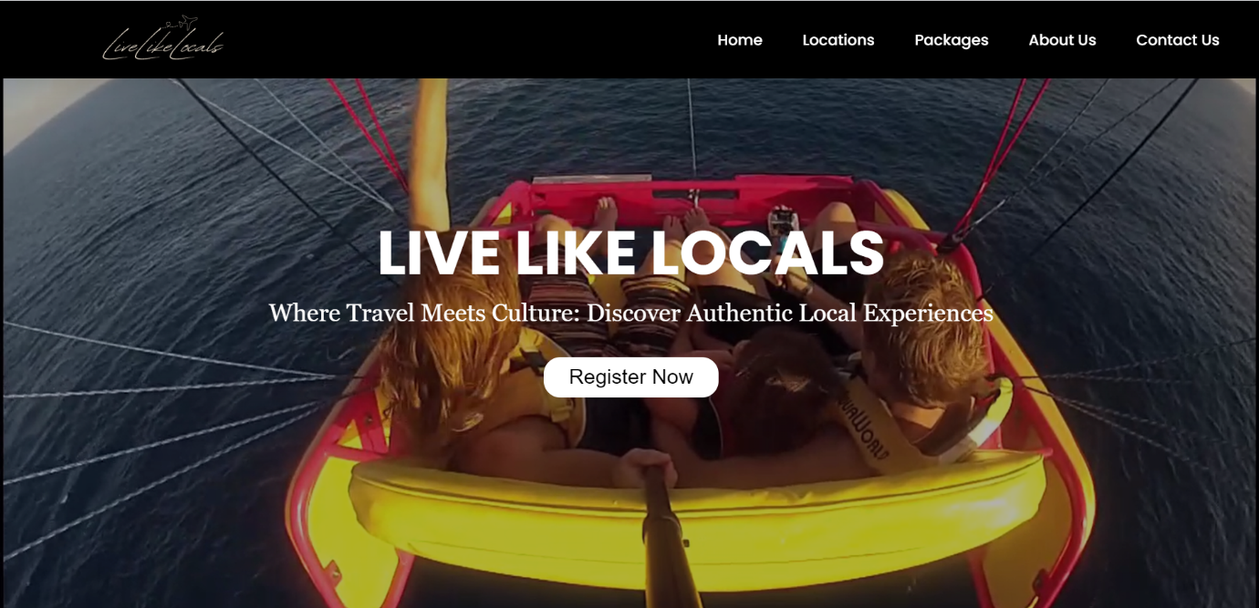

Figure 1:Home Page

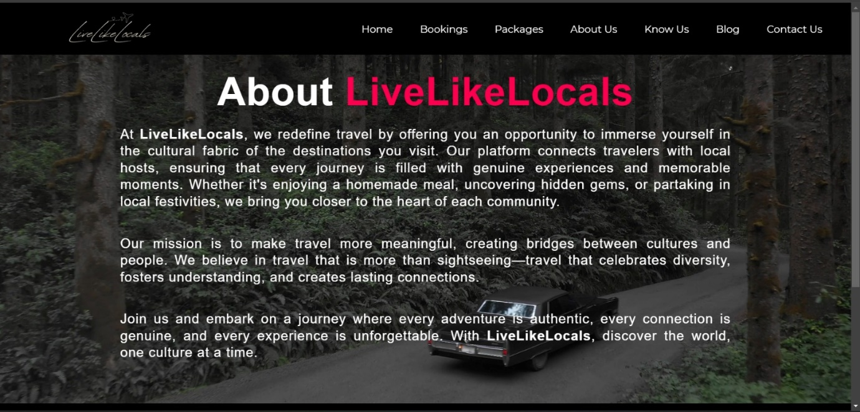

Figure 2: About Page

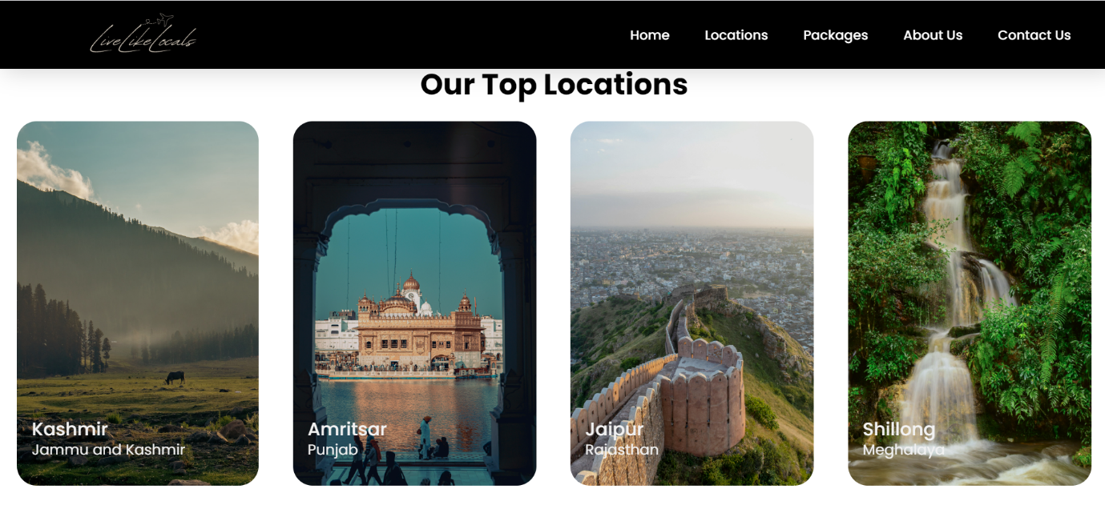

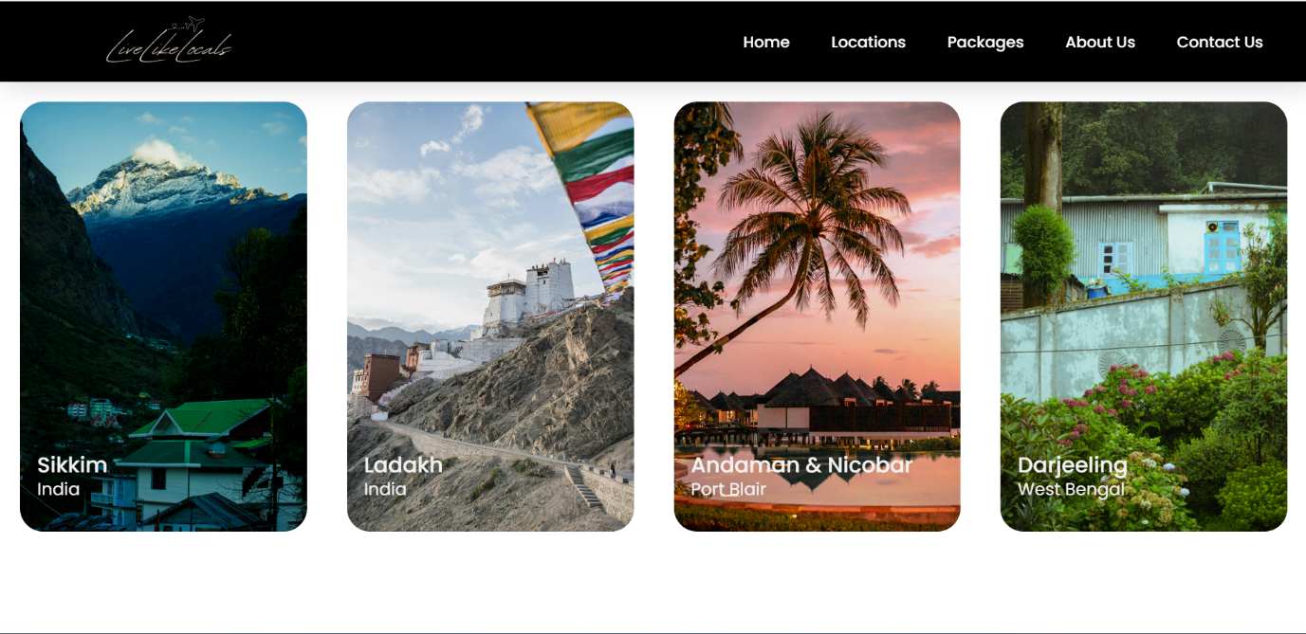

Figure 3: Locations

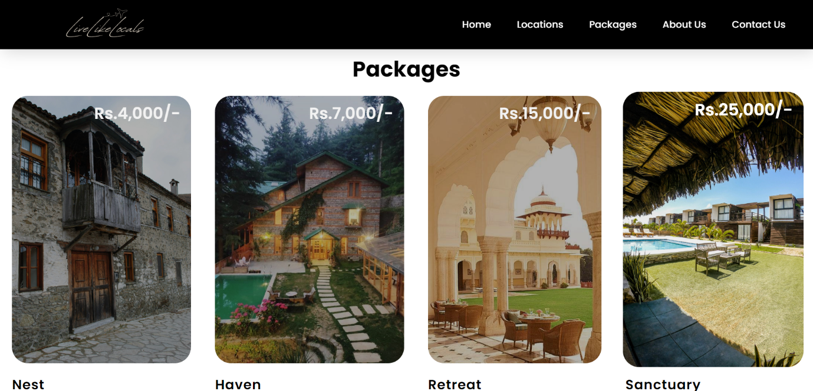

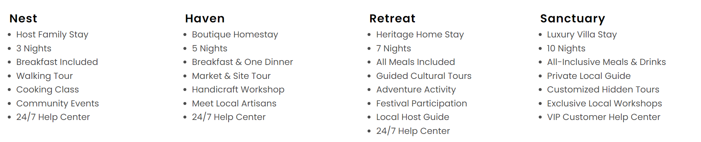

Figure 4: Packages

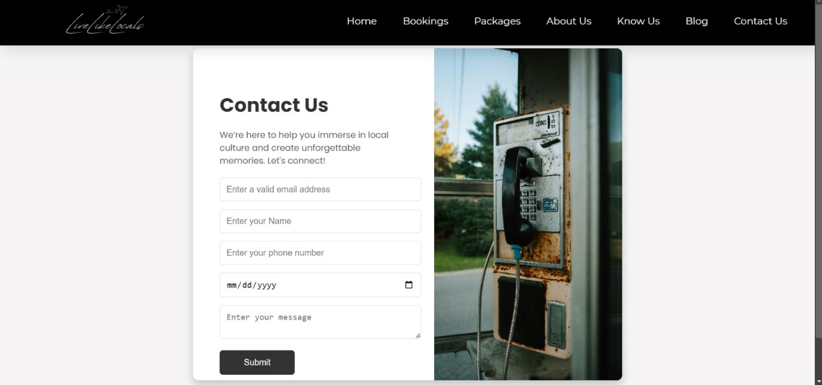

Figure 4: Contact Us

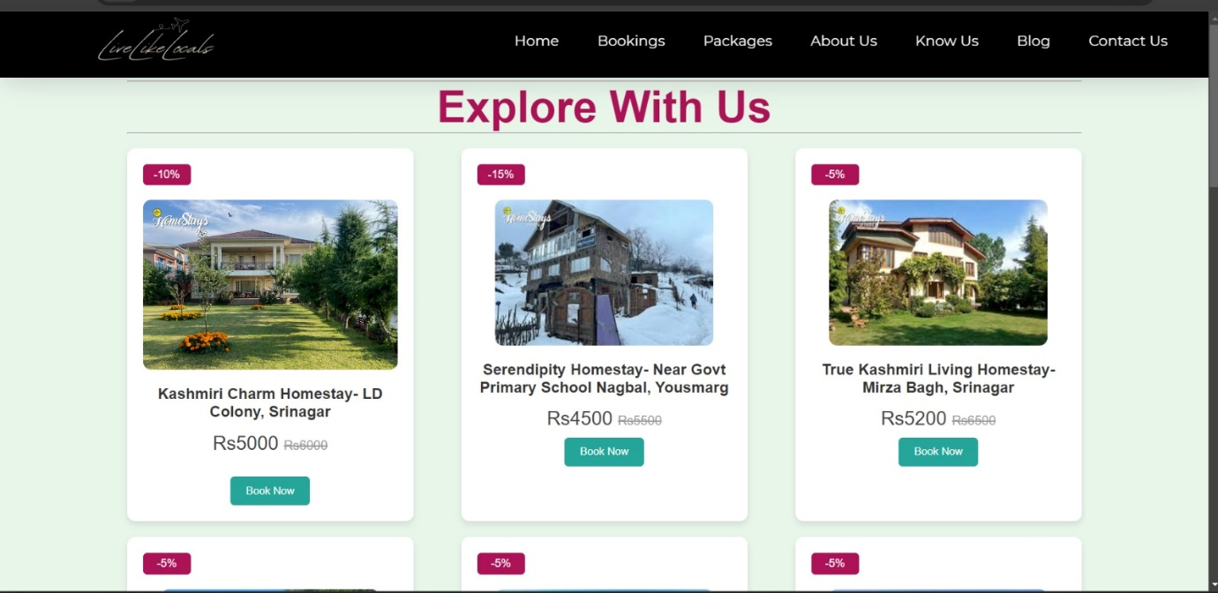

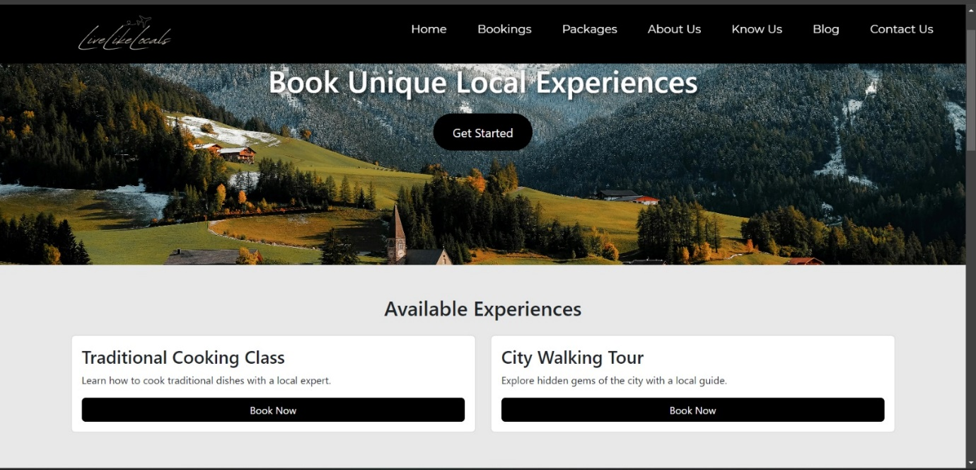

Figure 6: Bookings

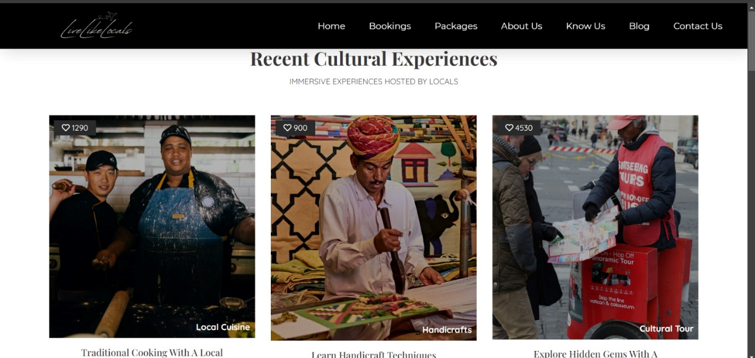

Figure 7: Cultural Experiences

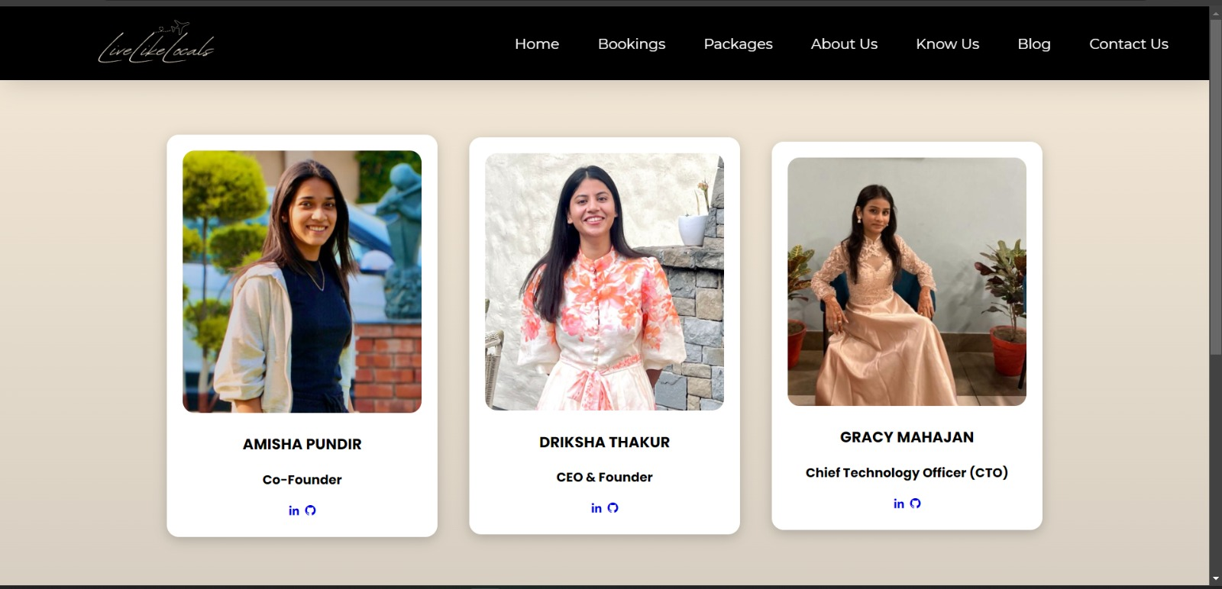

Figure 8: Know Us

**7) CONCLUSION**

The LiveLikeLocals project represents a significant evolution in the way we think about travel, shifting the focus from traditional, tourist-centric approaches to a model that emphasizes authentic, immersive experiences. By connecting travellers with local hosts and guides, the platform enables users to explore destinations through the eyes of those who live there, offering a deeper understanding and appreciation of the local culture, traditions, and daily life. This approach not only makes travel more meaningful but also creates lasting memories and personal connections that go beyond the typical tourist experience. One of the most impactful aspects of LiveLikeLocals is its commitment to supporting local communities. By facilitating direct interactions between travellers and local residents, the platform ensures that the economic benefits of tourism are more fairly distributed, helping to sustain small businesses, artisans, and cultural practitioners. This focus on community-based tourism contributes to the preservation of cultural heritage and promotes sustainable economic development, which is crucial for the long-term vitality of many destinations. Moreover, providing ongoing support and training for local hosts can help them continuously improve the quality of their offerings, ensuring that they meet the evolving expectations of global travellers. By focusing on these areas for future development, LiveLikeLocals has the potential to further enhance its impact on both travellers and local communities, solidifying its role as a leader in responsible, immersive travel. In summary, LiveLikeLocals is more than just a travel platform; it is a catalyst for a new kind of tourism that prioritizes cultural exchange, community empowerment, and environmental sustainability. As the platform continues to grow and adapt to the needs of its users, it will not only enhance the travel experience but also contribute to the preservation and celebration of the world's diverse cultures and environments.

**8)REFERENCES**

* <https://www.w3schools.com/tags/tag_html.asp>
* <https://www.w3schools.com/w3css/w3css_tags.asp>
* <https://youtu.be/cgV2tN8gxCg?si=l7DSff_kZgZObvwo>
* <https://youtu.be/6AxnXWaDL-U?si=ojHgTsOU8sd4Siu1>